**Game Design Doc**

Initial design is to create a puzzle game based on the international space station, implement a GUI using QT, story as follows:

**Intro:** SOS signal sent out from ISS, complete loss of communication after small collision with space debris.

Rescue crew sent up to recover astronauts from ISS

When crew arrives, they find entire station on lockdown, player must try open up each hatch to further explore station.

They establish audio contact with one of the surviving astronauts, Commander Vicki.

Vicki helps guide you to air hatch throughout game.

First connect to onboard computer to receive map and compass of ISS for navigation.

They figure out that the astronauts that were on board locked themselves in furthest part of station in air lock.

Vicki explains it was due to de-pressurization from space debris. Only part of station undamaged.

**Main Plot:** Navigate through several puzzles to further explore ISS and reach survivors.

Find hints and hear noises along the way of strange things happening.

**End Scene:** Finally reach air lock, get inside to find several dead bodies. The air hatch locks again, this time the rescue ship connected to ISS takes off, heading back to earth.

You hear Ali’s voice saying “thanks for the ride” through your headset as you stare at her body right beside you in airlock.

You have no idea who or what is in that ship heading back to earth.

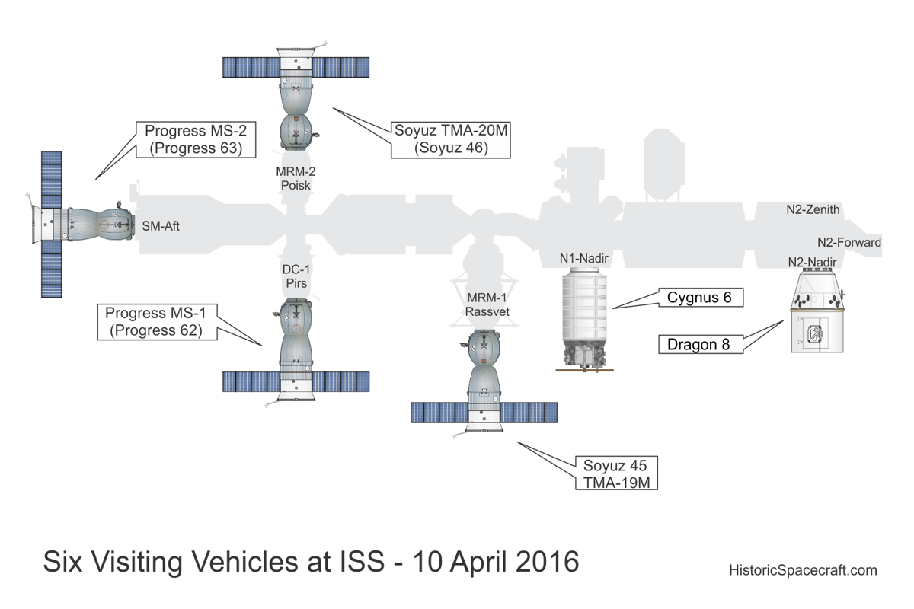

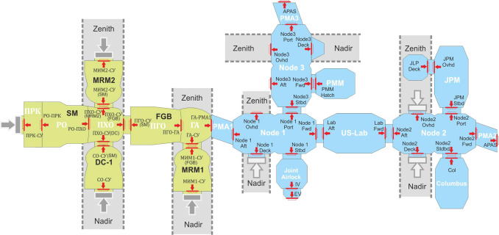

rule of three: A-B-C quest this will be the first 3 challenges after demo challenge

**Opening Scene:**

“Mission Control this is Commander Vicki of the ISS. I believe we have just been impacted by some space debris, some systems are down, running diagnostics…….”

*silence*

“Mission Control this is not looking good, the damage is-“

*radio static*

*silence*

Narrator Voice: “On March 20th 2026, we received this voice message from Commander Vicki on the ISS. This is the last communication we have had with the ISS in several days. We are ordering a Rescue mission, headed by **\*insert name here\*** and two other crew members.”

*space-ship counts down and takes off*

*dramatic music plays*

*game title shows on screen*

**Puzzles:**

**Criteria:**

1. **No. of possible solutions**
2. **No. of steps required**
3. **No. of options the player can choose from at each moment**
4. **Which mechanics the player needs to be familiar with beforehand.**

**Use assumptions the player will make. Incorporate assumption to make puzzle easier. Ensure that assumption results in failure of puzzle to make it more difficult.**

**Problem:** Door wont open without two buttons on different side of the room being opened.

**Solution:** Use another object/item in the room to hold down one button while you press the other.

**Problem:** Certain door won’t open due to lack of power.

**Solution:** Wait until ISS spins to face sun, to have enough power to open door.

**Problem:** Cannot find specific item with notorious noise. Eg. Watch, alarm goes off at certain time.

**Solution:** Listen carefully when in each room to find it.

**Problem:** Will get sucked out of ISS when hatch needs to be opened

**Solution:** Collect coper wire, nail and battery to make an electromagnet. Use this to stay connected to flat metal surface.

**Problem:** Door is voice activated. Your normal voice does not work.

**Solution:** Inhale a small amount of helium to alter your voice.

**Problem:** Need a specific item to progress through. Checked each room and nowhere to be found.

**Solution:** Move another item to find the item you are looking for.

G & E: Both rooms depressurized, when entering to reseal, you will be sucked out.

Sol: Electromagnet and Rope. Use ducttape, silicon to seal with large panel.

**Map Design + GUI Design Overview:**

